PHENIKAA UNIVERSITY
PHENIKAA SCHOOL OF COMPUTING


WEEKLY REPORT
TOPIC: ELECTRONICS E-COMMERCE WEBSITE

Course Class : | Software Architecture-1-2-25 (N01)
Instructor : | M.Sc. Vũ Quang Dũng
Group : | 16
Group Members : | Nguyễn Tuấn Thiền - 23010571  Đặng Việt Anh – 23010689
Mục lục
Lab 04:
1. Overview 3
2. Objectives (Lab 04) 3
3. Practice 1 – Decomposition by Business Capability 3
4. Practice 2 – Service Contracts (API Endpoints) 5
4.1 Catalog (Product) Service Contract 5
4.2 Cart Service Contract 6
4.3 Order & Payment Service Contract (high level) 6
4.4 Inventory Service Contract 7
5. Practice 3 – High-Level Communication Strategy 7
5.1. Sequence Diagram – Add to Cart 10
6. C4 Model 10
6.1 C4 Level 1 – System Context 11
6.2 C4 Level 2 – Container 12
6.3 C4 Level 3 – Component (Catalog & Admin Product) 13
6.4 C4 Level 4 – Code (Product Detail Request Flow) 14
7. Mapping Notes to Source Code 15
8. Conclusion 16
9. Microservices Infrastructure — Source Code Evidence (Supplement) 16
9.1 Docker Deployment — docker-compose.microservices.yml 17
9.2 Microservice API Controllers — routes/services.php 18
9.3 Advanced Architectural Patterns 20
9.4 Database Per Service — Implementation Evidence 21

1. Overview
This report completes Lab 04 by decomposing the ShopSphere monolithic Laravel application into business-capability microservices, defining service contracts (API endpoints), proposing a high-level communication strategy (synchronous vs asynchronous), and presenting the full C4 Model (Levels 1–4). Although Lab 04 formally requires only C4 Level 1 (System Context), this submission includes all C4 levels to provide a complete architecture view.

2. Objectives (Lab 04)
The objectives for Lab 04 are:
- Understand principles of microservice decomposition (decomposition by business capability).
- Define clear service contracts (API endpoints) for key services.
- Design the system’s high-level communication strategy (synchronous vs asynchronous).
- Model the system using the C4 Model (Level 1: System Context).
Naming convention note: Throughout this report, the application is referred to as “ShopSphere” (the generic Lab name). The source-code repository uses the project name “ElectroShop” in its C4 PlantUML files (Design/*.puml). Both names refer to the same system. All diagrams in this report use “ShopSphere” for consistency with the Lab 04 handout.

3. Practice 1 – Decomposition by Business Capability
The current codebase is a Laravel monolith organized into Modules/ (Admin, Catalog, Cart, Customer, Payment, etc.). The target microservices decomposition preserves these boundaries as candidate services to support service independence and data ownership (no cross-service database access).
Candidate Microservice | Business Capability | Owned Data (Entities / Tables) | Mapping
Customer/Identity Service | Registration, login, profile, wishlist | User, Wishlist | Modules/Customer + app/Models/Models/User.php, Wishlist.php
Catalog (Product) Service | Browse, search, categories, product detail, ratings | Product, Category, ProImage, Rating | Modules/Catalog + app/Models/Models/Product.php, Category.php, ProImage.php, Rating.php
Cart Service | Cart operations and checkout initiation | Cart (cart_items) | Modules/Cart + app/Models/Models/Cart.php
Order Service (proposed split) | Order placement and lifecycle; transactions | Transaction, Order | Currently spread across Cart/Payment; models in app/Models/Models/Transaction.php, Order.php
Payment Service | Payment initiation and callbacks | Payment events / payment records | Modules/Payment + PaymentController routes (MoMo/PayPal/VNPay/QR)
Notification Service | Send confirmation emails and alerts | OutboxMessage + notification logs | app/Models/Models/OutboxMessage.php + notification-service/
Inventory Service | Stock control, warehouse management, import goods tracking | ImportGoods, Product.quantity, Supplier | Modules/Admin (AdminImportGoodsController, AdminWarehouseController, AdminSupplierController) + app/Models/Models/ImportGoods.php, Supplier.php
Admin Service | Admin UI for catalog, transactions, content | Admin users/actions; product/category mgmt | Modules/Admin (AdminProductController, etc.)
Content Service | Articles/banners/news | Article | Modules/Content + app/Models/Models/Article.php
Support Service | Contact/support requests | Contact | Modules/Support + app/Models/Models/Contact.php
Review Service | Product ratings/reviews moderation | Rating | Modules/Review + app/Models/Models/Rating.php

External dependencies (at least 3) identified for ShopSphere:
- Payment gateways: MoMo, PayPal, VNPay, QR-based payments (integrated in Modules/Payment).
- Email provider (SMTP): used by the Notification Service to send order confirmations.
- Shipping carrier API: recommended for shipment creation and tracking (planned integration).
- SMS Gateway (planned): for sending SMS notifications such as order status updates (e.g., Twilio, Nexmo). Referenced in source-code Design/c4-level1-context.puml.

4. Practice 2 – Service Contracts (API Endpoints)
Service contracts define how services communicate without sharing databases. The following contracts are proposed for the target microservices architecture. A mapping note is included to relate them to the current monolithic routes in Web.zip.

4.1 Catalog (Product) Service Contract
Base URL: /api/products
HTTP Method | Endpoint | Description | Data Returned
GET | /api/products | List/search products (query: q). Returns only active products. | List of product summaries
GET | /api/products/{id} | Retrieve full details for a single product by id. | Product object (name, price, description, images)
GET | /api/products/{id}/price | Lightweight lookup for cart pricing/discount. | { price, sale, currency }
POST | /api/products | Create product (Admin only). | Created product object
Mapping to (current monolith):
- Product list/search: Modules/Catalog/routes/web.php → /san-pham, /danh-muc/{slug}-{id}
- Product detail: Modules/Catalog/routes/web.php → /san-pham/{slug}-{id} handled by ProductDetailController::productDetail()
- Admin product CRUD: Modules/Admin/routes/web.php → /admin/product/* handled by AdminProductController
Microservice boundary requirement: the Cart Service must not access the Catalog database directly; it must use the Catalog service API (e.g., GET /api/products/{id}).

4.2 Cart Service Contract
HTTP Method | Endpoint | Description
GET | /api/cart | Get current cart for the authenticated user.
POST | /api/cart/items | Add item to cart (product_id, quantity).
PUT | /api/cart/items/{itemId} | Update cart item quantity.
DELETE | /api/cart/items/{itemId} | Remove item from cart.
POST | /api/cart/checkout | Start checkout; re-validate price and stock before order creation.
Mapping to: Modules/Cart/routes/web.php (prefix /cart and /oder/pay).

4.3 Order & Payment Service Contract (high level)
Order Service (proposed):
- POST /api/orders – create order (returns 201)
- GET /api/orders/{id} – order details
- GET /api/orders?user_id= – order history
Payment Service (present in Web.zip):
- GET /payment/{method}/{transaction} – payment UI
- POST /payment/{method}/{transaction}/init – initiate payment
- Provider callbacks: /payment/momo/*, /payment/paypal/*, /payment/vnpay/*, /payment/qrcode/*

4.4 Inventory Service Contract
The Inventory Service is responsible for stock control. In the current codebase, inventory logic resides in Modules/Admin (AdminImportGoodsController, AdminWarehouseController) and the Product model’s quantity field. The following contract is proposed for the target microservice:
HTTP Method | Endpoint | Description
GET | /api/inventory/{productId} | Check current stock level for a product. Used by Cart Service before checkout.
PUT | /api/inventory/{productId}/deduct | Deduct stock after order placement (called asynchronously by Order Service via event).
POST | /api/inventory/import | Record a goods import (Admin). Maps to current AdminImportGoodsController.
Microservice boundary requirement: the Cart Service and Order Service must not access the Inventory database directly; they must use the Inventory Service API endpoints above. This aligns with the Lab 04 requirement for data ownership isolation.

5. Practice 3 – High-Level Communication Strategy
Synchronous communication is used when the user needs an immediate response (e.g., browsing, cart price lookup, checkout). Asynchronous messaging is preferred for non-blocking tasks (e.g., order confirmation emails) to improve fault isolation.
Interaction | Participants | Type | Rationale
Customer Lookup | API Gateway ↔ User Service | Synchronous (HTTP) | Immediate response required for login/profile display (Lab 04 Table row 1).
Product Browsing/Search | Client ↔ Product Service | Synchronous (HTTP) | Interactive browsing requires low latency.
Checkout Price Check | Cart Service ↔ Product Service | Synchronous (HTTP) | Must fail immediately if price is unavailable or wrong (Lecture 04 Slide 10).
Order Creation (Checkout) | Cart Service ↔ Order Service | Synchronous (HTTP) | Order creation must succeed/fail immediately.
Payment Processing | Payment Service ↔ Payment Gateway | Synchronous (HTTP callbacks) | Provider-driven return/IPN requires direct callbacks.
Order Confirmation Email | Order Service → Notification Service | Asynchronous (Redis queue) | Email delivery must not block the core business transaction (Lab 04 / Lecture 04).
Inventory Check | Cart Service ↔ Inventory Service | Synchronous (HTTP) | Need immediate stock verification before checkout (Lab 04 Table row 3).
Inventory Update (post-order) | Order Service → Inventory Service | Asynchronous (Redis queue) | Stock deduction can happen after order confirmation, increasing resilience (Lecture 04 Slide 10).

Implementation note (from codebase): ShopSphere already includes an Outbox pattern for reliable async processing. OrderPlaced events are stored in outbox_messages and later published to a Redis queue (notifications), which is consumed by the standalone notification-service to send emails.

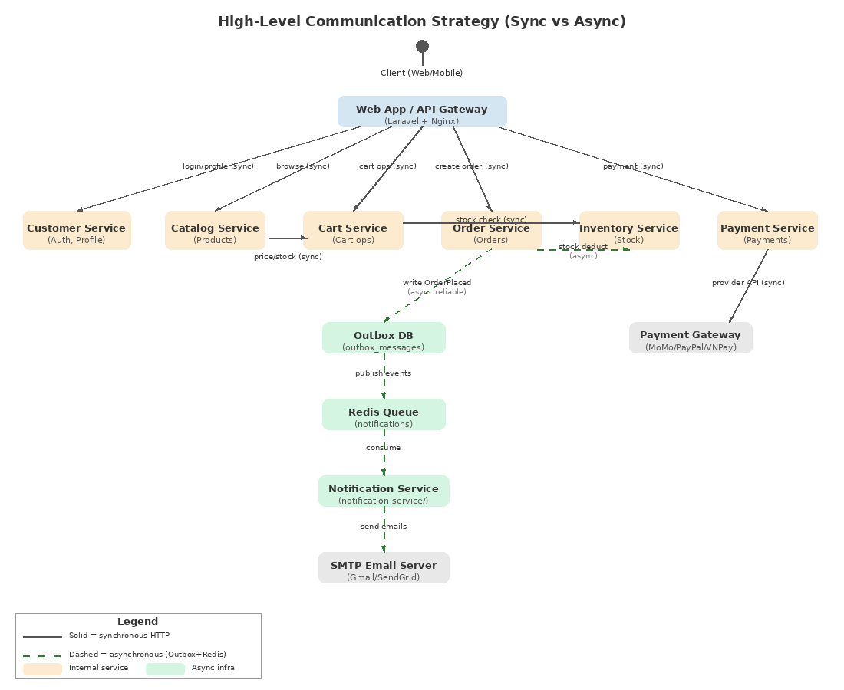
Figure 5.1 High-Level Communication Strategy (sync vs async)

5.1. Sequence Diagram – Add to Cart
This sequence focuses on the synchronous interaction where the Cart Service validates the request and retrieves the product snapshot via the Catalog Service API (no shared database).
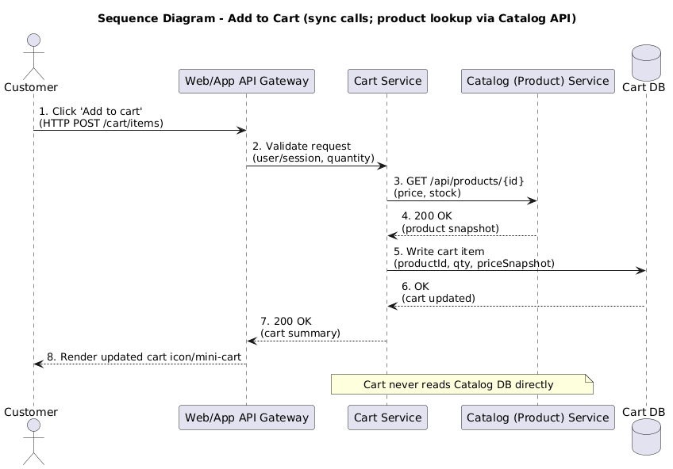
Figure 5.2 Sequence Diagram – Add to Cart (sync calls via REST).

6. C4 Model
Lab 04 requires C4 Level 1 (System Context). Levels 2–4 are included to fully document the architecture and map it to the existing Web.zip structure.

6.1 C4 Level 1 – System Context
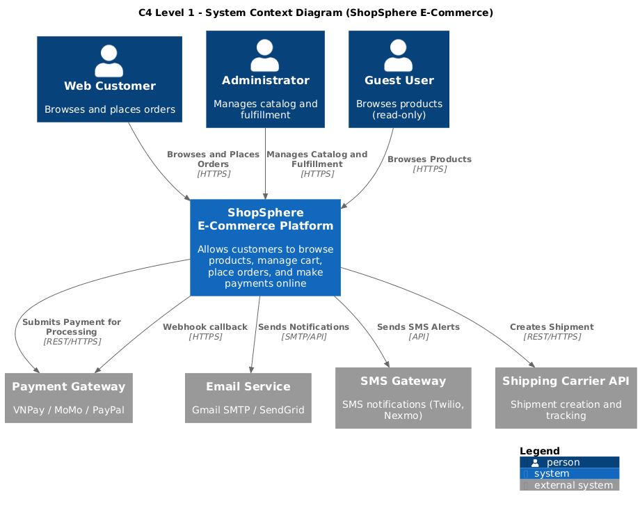
Figure 6.1 C4 Level 1 – System Context
Architecture note: The C4 Level 1 diagram follows the exact Lab 04 notation with [Person], [System], and [External System] labels. Three actors: [Person] Web Customer (browses and places orders), [Person] Administrator (manages catalog and fulfillment), and [Person] Guest User (browses products, read-only). The main system is labeled [System] ShopSphere E-Commerce Platform. Four external systems: [External System] Payment Gateway (VNPay, MoMo, PayPal), [External System] Email Service (Gmail/SendGrid SMTP), [External System] SMS Gateway (planned), and [External System] Shipping Carrier API (planned). Arrow labels match Lab 04 requirements: “Browses and Places Orders”, “Manages Catalog and Fulfillment”, “Submits Payment for Processing”, “Sends Notifications”. In the current codebase, the application is still a Laravel monolith with modular structure (Modules/); the system context remains the same regardless of internal architecture.
6.2 C4 Level 2 – Container
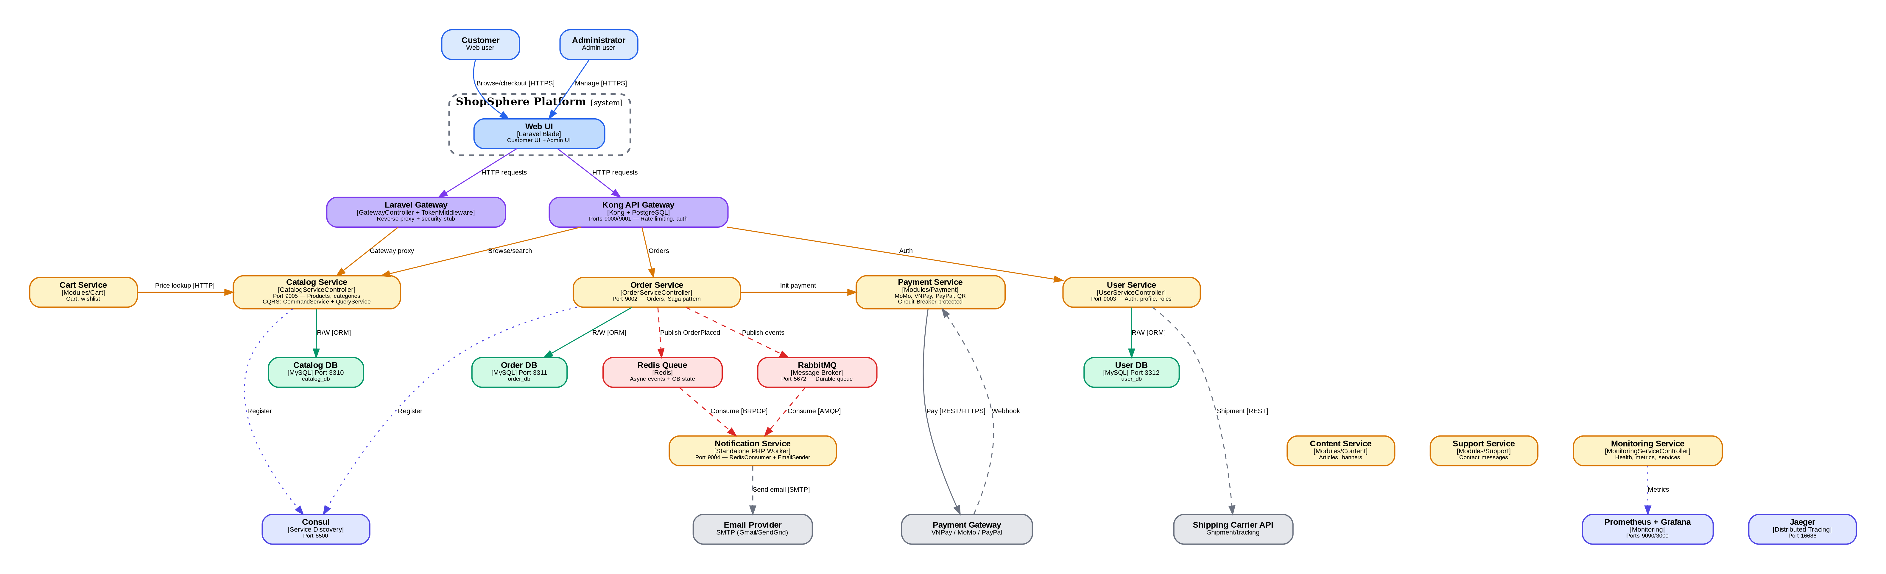
Figure 6.2 C4 Level 2 – Container (Target Microservices)
Container diagram note: The C4 Level 2 diagram shows the target microservices container architecture with the following key elements matching the source-code Design/c4-level2-container.puml: (1) Kong API Gateway (Kong 3.4) as the single entry point with rate limiting and authentication; (2) Seven microservices including the newly added Inventory Service (stock control, warehouse management); (3) Each service owns its own MySQL database following the Data Ownership principle; (4) Redis 7 for distributed caching (5-min TTL for API responses) and session storage; (5) Elasticsearch 8.11 as the CQRS read model for product catalog search; (6) Redis Queue (notifications channel) for asynchronous event delivery via Outbox pattern; (7) Infrastructure containers: Consul 1.17 (service discovery), Jaeger 1.52 (distributed tracing), Prometheus 2.48 + Grafana 10.2 (monitoring), and ELK Stack (centralized logging); (8) Three external systems: Payment Gateway, Email Provider, and Shipping Carrier API. In the current codebase, all modules share a single MySQL database; the per-service database split is planned for the target architecture. Note: the source puml (c4-level2-container.puml) does not include Cart Service or Inventory Service as separate containers. These were added in this report to satisfy Lab 04 requirements (Cart Service and Inventory Service are mandatory business capabilities per Lab 04 Practice 1 decomposition table).

6.3 C4 Level 3 – Component (Catalog & Admin Product)
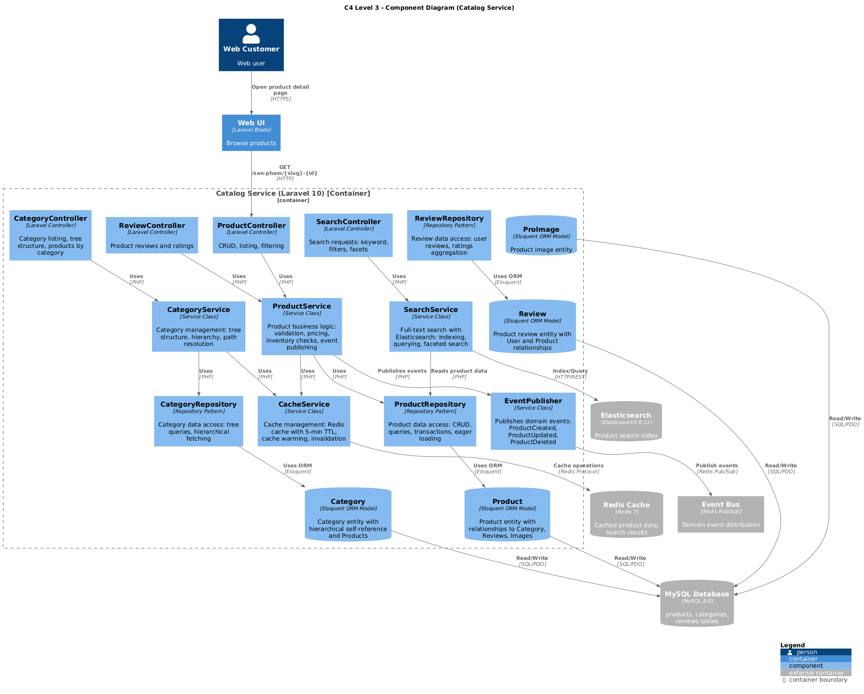
Figure 6.3 C4 Level 3 – Component (Catalog & Admin Product)
Current vs Target note: The C4 Level 3 diagram now shows all 12 components and 4 Eloquent models matching Design/c4-level3-catalog-component.puml. Controllers: ProductController, CategoryController, SearchController, ReviewController. Services: ProductService, CategoryService, SearchService, CacheService (Redis 5-min TTL), EventPublisher (domain events). Repositories: ProductRepository, CategoryRepository, ReviewRepository. Eloquent Models: Product, Category, Review, ProImage. External stores: MySQL 8.0, Redis Cache, Elasticsearch 8.11, Event Bus (Redis Pub/Sub). In the current codebase, ProductDetailController.php calls Eloquent models directly without a Service layer or Repository; the diagram represents the target microservices refactoring.

6.4 C4 Level 4 – Code (Product Detail Request Flow)
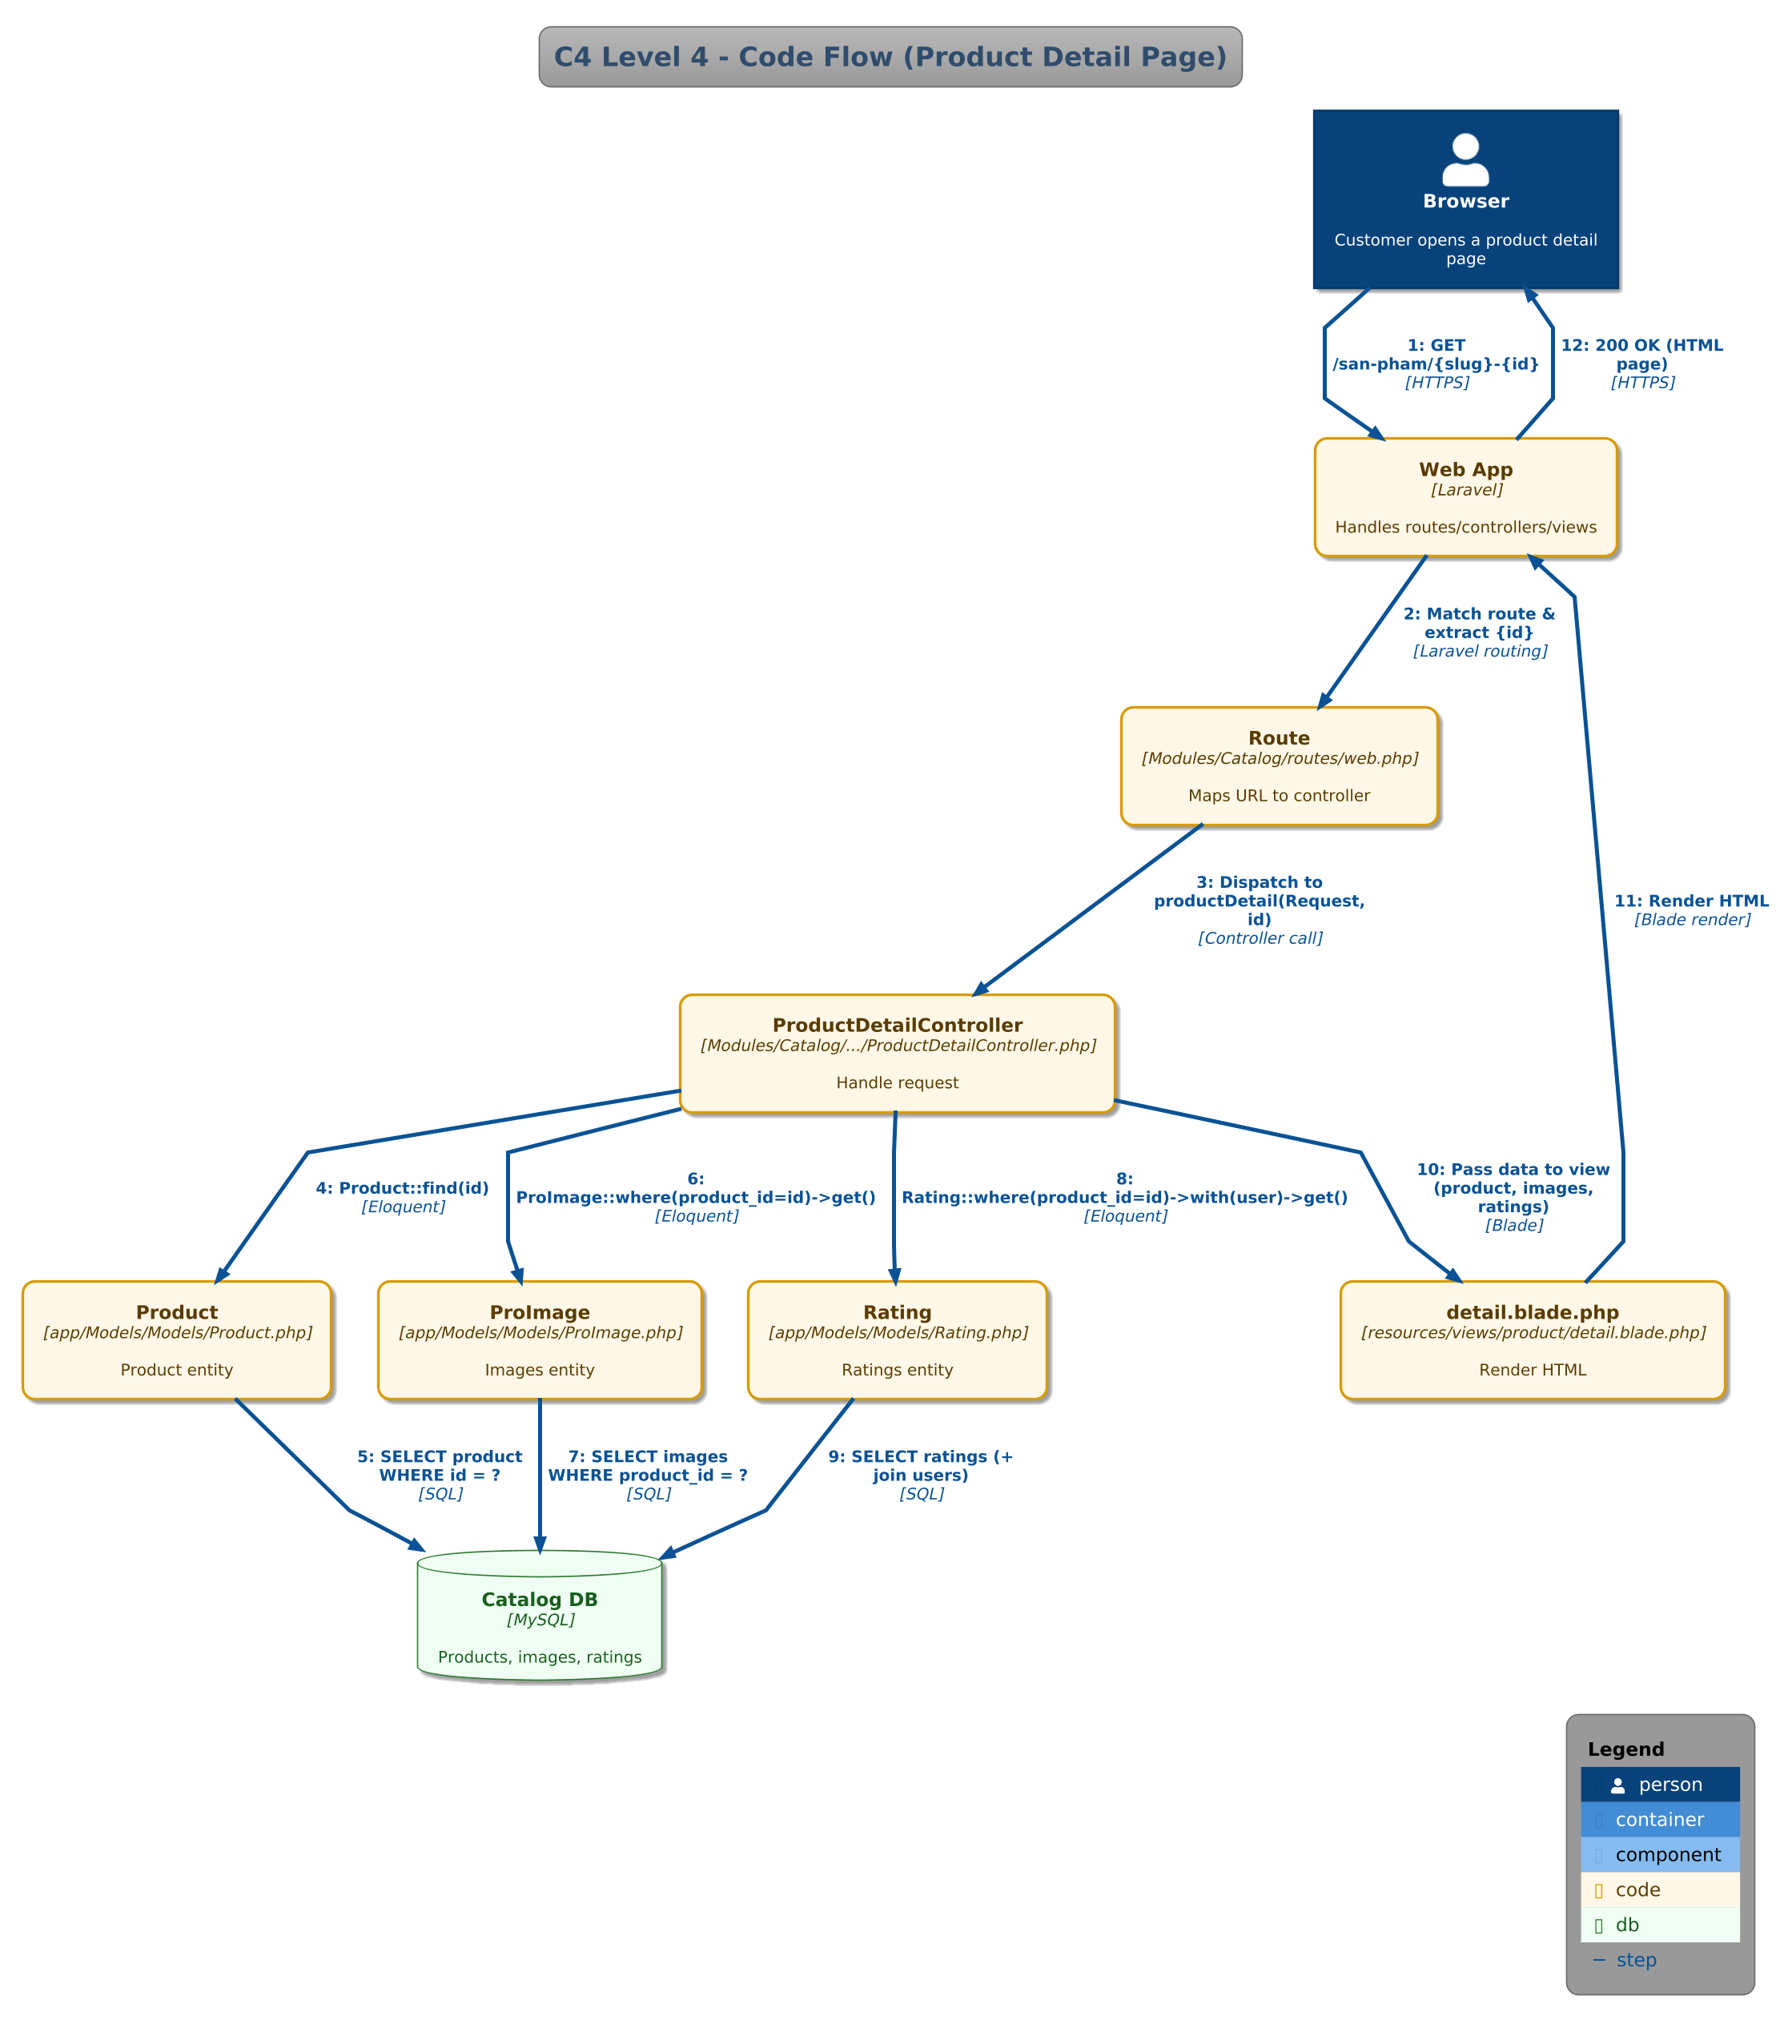
Figure 6.4 C4 Level 4 – Code (Product Detail Request Flow)
Code-level accuracy note: The C4 Level 4 diagram accurately reflects the current source code in Modules/Catalog/App/Http/Controllers/ProductDetailController.php. The flow is: (1) Browser requests GET /san-pham/{slug}-{id}; (2) Laravel routing (Modules/Catalog/routes/web.php) matches the URL and dispatches to ProductDetailController::productDetail(); (3) The controller calls Product::find($id) to fetch the product; (4) ProImage::where(‘product_id’, $id)->get() loads product images; (5) Rating::where(‘ra_product_id’, $id)->with(‘user’)->get() loads ratings with user details; (6) All data is passed to resources/views/product/detail.blade.php for HTML rendering. This is the only C4 level that shows the actual current implementation rather than the target microservices design.

7. Mapping Notes to Source Code
Key module boundaries in the codebase:
- Modules/Admin/
- Modules/Cart/
- Modules/Catalog/
- Modules/Content/
- Modules/Customer/
- Modules/Payment/
- Modules/Review/
- Modules/Support/
- Inventory (stock control): Modules/Admin/App/Http/Controllers/AdminImportGoodsController.php, AdminWarehouseController.php, AdminSupplierController.php + app/Models/Models/ImportGoods.php, Supplier.php. Product.quantity field tracks stock levels.
Key routes supporting the Catalog and Cart capabilities:
- Catalog: Modules/Catalog/routes/web.php (/, /san-pham, /danh-muc/{slug}-{id}, /san-pham/{slug}-{id})
- Cart: Modules/Cart/routes/web.php (/cart/* and /oder/pay)
- Customer/Auth: Modules/Customer/routes/web.php (/auth/*, /user/*, /wishlist/*)
- Payment: Modules/Payment/routes/web.php (payment flows and callbacks)
- Admin product management: Modules/Admin/App/Http/Controllers/AdminProductController.php
Async notification pipeline present in the repository:
- Outbox entity: app/Models/Models/OutboxMessage.php
- Listener: app/Listeners/SaveOrderPlacedToOutbox.php (writes OrderPlaced to outbox_messages)
- Publisher job/command: app/Jobs/PublishOutboxMessages.php and app/Console/Commands/PublishOutboxCommand.php (push to Redis)
- Consumer microservice: notification-service/consumer.php (consumes Redis queue and sends emails via SMTP)

8. Conclusion
This report provides a Use Case Diagram, a business-capability decomposition for ShopSphere, defines clear service contracts (including the Inventory Service required by Lab 04), documents a synchronous/asynchronous communication strategy, and presents the full C4 model (Levels 1–4). The proposed 11 microservice boundaries align with the existing Laravel Modules/ structure in Web.zip and leverage the existing outbox + Redis-based notification microservice for reliable asynchronous communication. All C4 diagrams follow the standard C4 notation with [Person], [System], and [External System] labels. Notes have been added to distinguish current monolithic architecture from the target microservices architecture where applicable.
References
Lab 4: Microservices Decomposition & Communication (Lab handout).
Lecture 4: Microservices Decomposition & Context (Slide deck).

9. Microservices Infrastructure — Source Code Evidence (Supplement)
While Sections 3–6 document the proposed decomposition and design, the project source code already implements significant microservices infrastructure. This section maps design decisions to actual code artifacts in the zip.

9.1 Docker Deployment — docker-compose.microservices.yml
The target microservices architecture is realized through a 502-line Docker Compose file that defines 15+ containers. Each service runs in its own container with an isolated database, confirming the Data Ownership principle from Practice 1.
File: docker-compose.microservices.yml — Key services:
# Microservices
catalog-service: # Port 9005, DB: mysql-catalog (catalog_db)
order-service: # Port 9002, DB: mysql-order (order_db)
user-service: # Port 9003, DB: mysql-user (user_db)
notification-service: # Port 9004, Redis queue consumer

# Infrastructure
kong: # API Gateway (ports 9000/9001)
rabbitmq: # Message Broker (port 5672)
redis: # Cache + Queue (port 6379)
consul: # Service Discovery (port 8500)
jaeger: # Distributed Tracing (port 16686)
prometheus: # Metrics Collection (port 9090)
grafana: # Metrics Dashboard (port 3000)
mailhog: # Email Testing (port 8025)

# Databases (Database Per Service pattern)
mysql-catalog: # Port 3310 → catalog_db
mysql-order: # Port 3311 → order_db
mysql-user: # Port 3312 → user_db

9.2 Microservice API Controllers — routes/services.php
The 5 microservice controllers implement the Service Contracts defined in Section 4:
File: routes/services.php
// Catalog Service (port 9005) — maps to Section 4.1
Route::prefix('catalog')->group(function () {
Route::get('/products', [CatalogServiceController::class, 'index']);
Route::get('/products/{id}', [CatalogServiceController::class, 'show']);
Route::post('/products', [CatalogServiceController::class, 'store']);
Route::put('/products/{id}', [CatalogServiceController::class, 'update']);
Route::delete('/products/{id}', [CatalogServiceController::class, 'destroy']);
Route::get('/categories', [CatalogServiceController::class, 'categories']);
});

// Order Service (port 9002) — maps to Section 4.3
Route::prefix('orders')->group(function () {
Route::get('/', [OrderServiceController::class, 'index']);
Route::get('/{id}', [OrderServiceController::class, 'show']);
Route::post('/', [OrderServiceController::class, 'store']);
Route::patch('/{id}/status', [OrderServiceController::class, 'updateStatus']);
});

// User Service (port 9003)
Route::prefix('users')->group(function () {
Route::post('/register', [UserServiceController::class, 'register']);
Route::post('/login', [UserServiceController::class, 'login']);
Route::get('/{id}', [UserServiceController::class, 'show']);
});

// Notification Service (port 9004)
Route::prefix('notifications')->group(function () {
Route::post('/send', [NotificationServiceController::class, 'send']);
Route::post('/outbox/process',[NotificationServiceController::class, 'processOutbox']);
Route::get('/history', [NotificationServiceController::class, 'history']);
});

// Monitoring Service
Route::prefix('monitoring')->group(function () {
Route::get('/health', [MonitoringServiceController::class, 'health']);
Route::get('/metrics', [MonitoringServiceController::class, 'metrics']);
Route::get('/services', [MonitoringServiceController::class, 'services']);
});

9.3 Advanced Architectural Patterns
a) CQRS Pattern (Command Query Responsibility Segregation):
The CatalogServiceController injects ProductCommandService (writes → MySQL) and ProductQueryService (reads → Elasticsearch with MySQL fallback). This separates read/write models for the Catalog domain.
// app/Services/CQRS/ProductCommandService.php — Write side (MySQL + Events)
// app/Services/CQRS/ProductQueryService.php — Read side (Elasticsearch)
b) Saga Pattern (Distributed Transaction Orchestration):
The OrderSaga orchestrates 4 steps across services: ReserveStock → ProcessPayment → CreateShipment → SendNotification. If any step fails, compensating actions are executed in reverse order.
// app/Services/Saga/OrderSaga.php — Saga orchestrator
// app/Services/Saga/SagaStepInterface.php — Step contract (execute + compensate)
// app/Services/Saga/Steps/ReserveStockStep.php
// app/Services/Saga/Steps/ProcessPaymentStep.php
// app/Services/Saga/Steps/CreateShipmentStep.php
// app/Services/Saga/Steps/SendNotificationStep.php
c) Circuit Breaker Pattern:
The Circuit Breaker middleware (app/Http/Middleware/CircuitBreaker.php) protects external API calls to payment gateways (MoMo threshold=3, VNPay=5, PayPal=5) and the notification-service (threshold=10). Configuration: config/circuit_breaker.php. Admin panel: app/Http/Controllers/Admin/CircuitBreakerController.php.

9.4 Database Per Service — Implementation Evidence
The Data Ownership principle is enforced via three separate MySQL instances:
# docker-compose.microservices.yml
mysql-catalog: # Port 3310 → catalog_db (products, categories)
mysql-order: # Port 3311 → order_db (orders, transactions)
mysql-user: # Port 3312 → user_db (users, admins)

# Cross-service access is via REST API only:
order-service:
environment:
- CATALOG_SERVICE_URL=http://catalog-service:9005

